|  |  |  |  |  |
| --- | --- | --- | --- | --- |
| Fresh Navel Oranges - Shop Fruit at H-E-BCara Cara - Summer Citrus | Fresh Gala Apples - Shop Fruit at H-E-BFresh Red Delicious Apples - Shop Fruit at H-E-B | Tomatillos or Green Tomatoes? That is the question. - GoFreshJalapeno Peppers - Hausbeck | FreshPoint | Cucumbers, English | Iceberg Lettuce Deserves More Than the Wedge Salad | The New Yorker |
| NAVEL & CARA CARA  2lbs/$1.00  LB.  ORANGES | GALA & RED  APPLES | JALAPEÑO  69¢LB.    & TOMATILLO REGULAR | LARGE  CUCUMBERS  2for/$1.00 | FRESH  ICEBERG LETTUCE  99¢EA. |

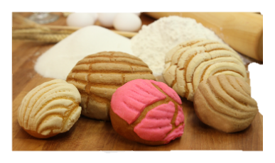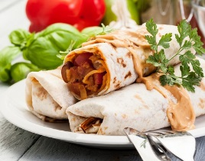

Try our Bakery Next Door!

Try our Hot Food Next Door!

MON-SAT

SUNDAY

Store Hours: 7am-8:30pm 7am-8:00pm

5040 Franklin Blvd Sacramento Ca, 95820 (916)455-4448

69¢LB.

¢

Fresh Produce

$2.79 LB.

$4.29 LB.

|  |  |  |  |  |
| --- | --- | --- | --- | --- |
| Chicken Drumsticks – Laramart | Thai-Braised Beef Shanks and Fresh Pickled Vegetable Salad | Queso png 3 » PNG Image  Fresh Meats | raw pork rib isolated on white Stock Photo by Jultud | PhotoDune[Related image](https://www.google.com/url?sa=i&rct=j&q=&esrc=s&source=images&cd=&cad=rja&uact=8&ved=2ahUKEwjr18-ri5DZAhWFMGMKHeakBdIQjRx6BAgAEAY&url=https://www.instacart.com/safeway/products/10467-signature-kitchen-boneless-beef-round-rump-roast-usda-choice-per-lb&psig=AOvVaw1yy8vGq7UzUB66_WtXfO-g&ust=1517964937224678)[Image result for CHICKEN FAJITAS RAW](https://www.google.com/url?sa=i&rct=j&q=&esrc=s&source=images&cd=&cad=rja&uact=8&ved=2ahUKEwiXldS5h5DZAhUJ2GMKHcE8B40QjRx6BAgAEAY&url=https://www.pinterest.com/pin/517843657144112262/&psig=AOvVaw0R22ux4ll-lKcoQrJJXKr8&ust=1517964013870665) | 189 Pot Roast Isolated Stock Photos, Pictures &amp; Royalty-Free Images - iStock |
| CHICKEN  DRUMSTICKS  99¢ LB. | BEEF  SHANK  $3.99LB. | EL MEXICANO  QUESO FRESCO | COUNTRY STYLE  SPARE RIBS | BEEF RUMP  ROAST  $5.49LB. |

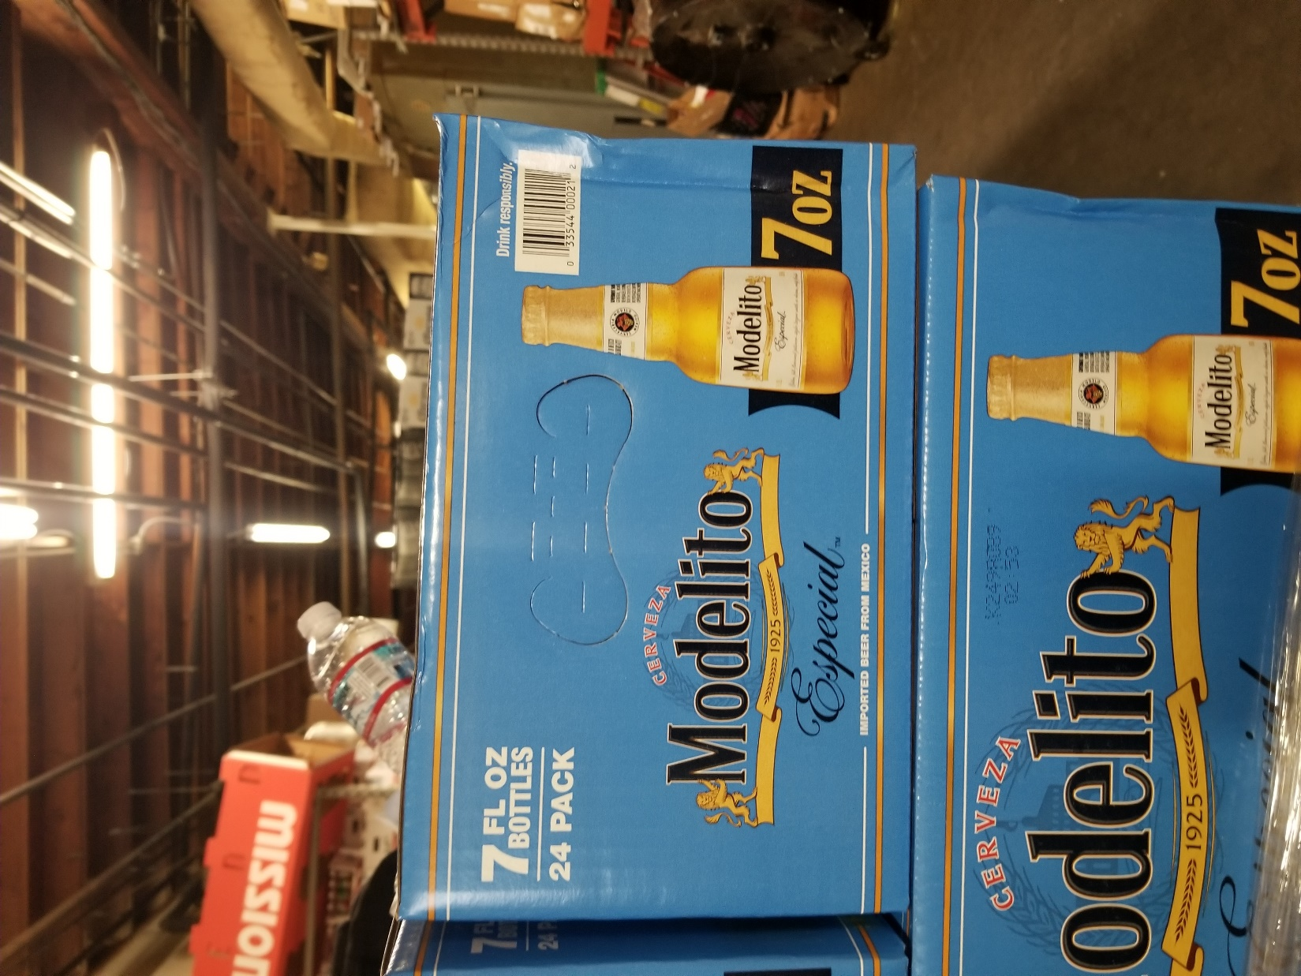

2for/$2.00

.

SINGLE: $1.50 EA.

|  |  |  |  |  |  |
| --- | --- | --- | --- | --- | --- |
| San Marcos Whole Jalapeno Peppers, 26 oz - Walmart.comSan Marcos Whole Jalapeno Peppers, 26 oz - Walmart.comSan Marcos Whole Jalapeno Peppers, 26 oz - Walmart.comSan Marcos Whole Jalapeno Peppers, 26 oz - Walmart.com | leche nido kinder 1 1 4 kg | Ibarra Mayoreoleche nido kinder 1 1 4 kg | Ibarra Mayoreoleche nido kinder 1 1 4 kg | Ibarra Mayoreo | Cuetara Marias Cookies 14.82oz Box-wholesale - SmartLoadUsa.com - Online  wholesale store of general merchandise and grocery itemsCuetara Marias Cookies 14.82oz Box-wholesale - SmartLoadUsa.com - Online  wholesale store of general merchandise and grocery items  Cuetara Marias Cookies 14.82oz Box-wholesale - SmartLoadUsa.com - Online  wholesale store of general merchandise and grocery itemsCuetara Marias Cookies 14.82oz Box-wholesale - SmartLoadUsa.com - Online  wholesale store of general merchandise and grocery items | Van de Kamp&#39;s Beer Battered Whole Fillets, 19.1 oz - Metro MarketFish Fillets | Van de Kamp&#39;sVan de Kamp&#39;s Beer Battered Whole Fillets, 19.1 oz - Metro MarketFish Fillets | Van de Kamp&#39;s  Grocery Deals | aloe coconut drink,therugbycatalog.comaloe coconut drink,therugbycatalog.com | Corona Extra 24pk Loose 12oz Bottles - Shenango BeveragePacifico (24 Pack) | CaboGrocery.comModelo Especial 24pk Bottles – Mission Wine &amp; Spirits[Image result for GOYA WHOLE PINTO BEANS 29OZ](https://www.google.com/url?sa=i&rct=j&q=&esrc=s&source=images&cd=&cad=rja&uact=8&ved=2ahUKEwil74CqkZDZAhXIMGMKHeOVABkQjRx6BAgAEAY&url=https://www.walmart.com/ip/Goya-Pinto-Beans-29-oz-Pack-of-12/19475535&psig=AOvVaw3g9Iyl6Xnu8hgMpcGAnumS&ust=1517966683603263) |
| SAN MARCOS  WHOLE JALAPENO PEPPERS 26oz | NESTLE NIDO KINDER  TODDLER MILK BEVERAGE  $14.95 EA.  1.4KG  !!!SAVE $4.OO!!! | CUETARA  MARIA’S COOKIES  14.82 oz  99¢EA..  . | VAN DE KAMP’S  BEER & CRISPY BATTERED FILLETS 10ct/19.1-19.45oz  $5.95EA..  . | PARROT  ALOE VERA DRINK W/PULP 1.5L  2for/$5.00+CRV.  SINGLE: $2.95 EA. | MODELO, PACIFICO & CORONA EXTRA 24pk/12oz  $26.99+CRV. |

**Sale Starts; 01/19/22-01/25/21**

**/6, 18**

**\*Prices are subject to change without prior notice* *While supplies last/ No rain checks Available\***